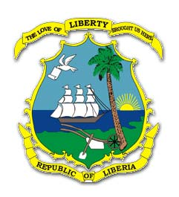

LIBERIA ANTI-CORRUPTION COMMISSION

LACC HOST ONE DAY FORUM FOR CIVIL SOCIETY AND ANTI-CORRUPTION INSTITUTIONS

Friday, June 24, 2022: The American diplomat said that the Biden-Harris Administration remains committed to the fight against corruption not only in Liberia but also worldwide.
He assured the participants that the United States government remains a friend of Liberia and urged everyone to join hands in the fight against corruption.
The one day forum was held under held under the theme, “Towards Strategizing to Ensure Speedy Passage of Anti-Corruption Bill Submitted by the Executive to the National Legislature”.
Some the Bills before the Legislature include, the Witness Protection; Whistler Blower among others.
The forum was organized by the LACC in partnership with the Center for Security Studies and Development (CENSSAD) with support from the U. N. Convention against Corruption.

